1. Consider the message signal  and set  *msec* as in Lab 2. Generate the FM signal , where , .

1. Plot  for i)  and ii) .

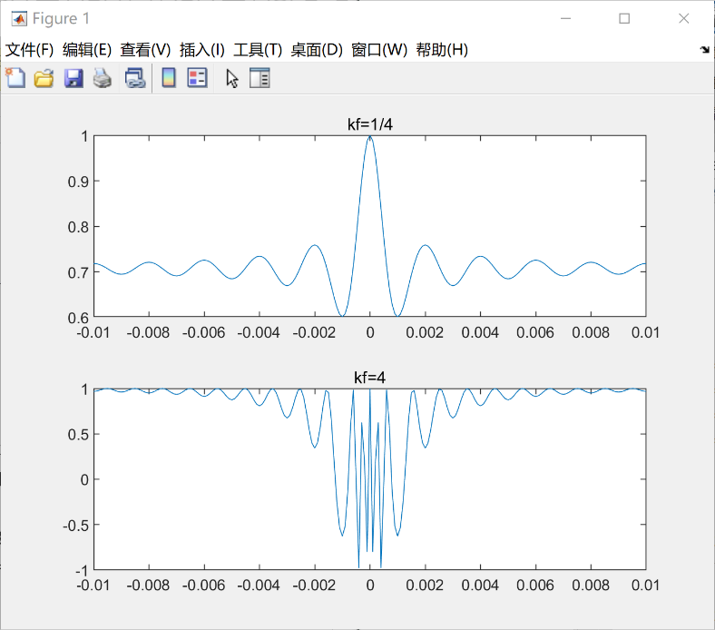

B) Determine and plot the magnitude of the Fourier transform of  using the FFT for i)  and ii) . The frequency resolution should be 1 *Hz*.



C) From the plots of B), determine the bandwidth  of the FM signals and verify if the results are consistent with the Carson’s formula , where  is the bandwidth of the message signal and  is the maximum deviation in instantaneous frequency due to the message signal.

D) What do you notice upon increasing ?

E) Can you approximate the maximum possible value of ?

F) Considering that the first minimum of the  function takes place at  (confirm it in Matlab!), what is the maximum value of  for correct detection of the message signal at the output of the discriminator demodulator?

G) How does the maximum of F) compare with the maximum value you determined in E)?